**DATA FLOW DIAGRAM OF TESI MANAGEMENT**

**CONTEX DIAGRAM OF TESI MANAGEMENT**

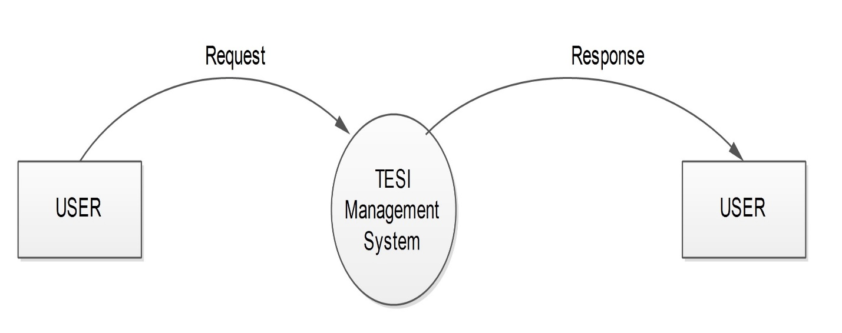

**LEVEL -1 DFD FOR ADMIN**

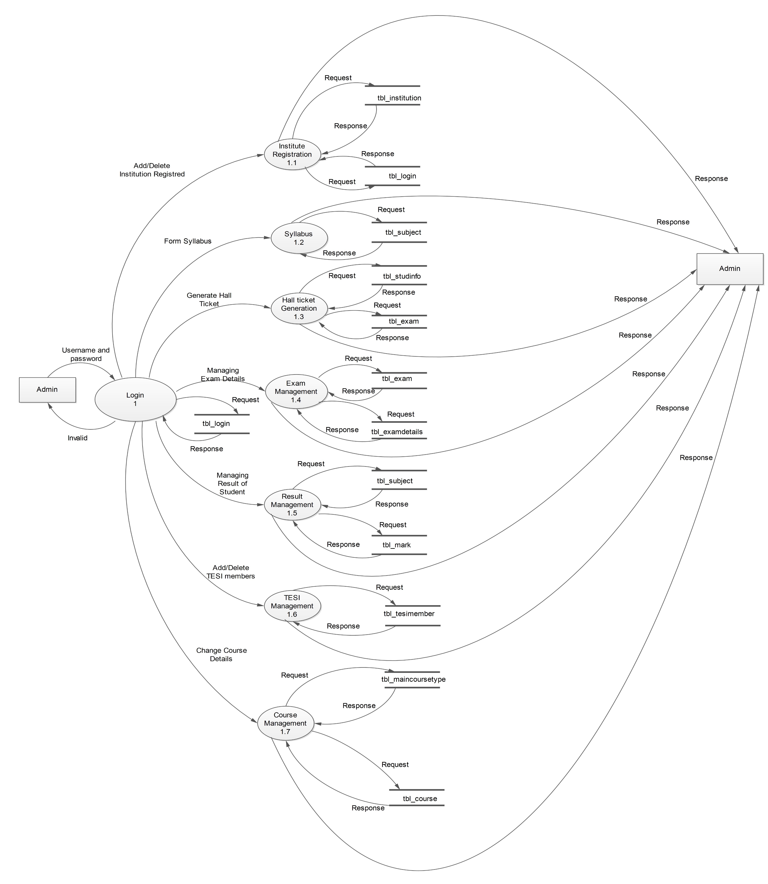

**LEVEL-1 DFD FOR INSTITUTION**

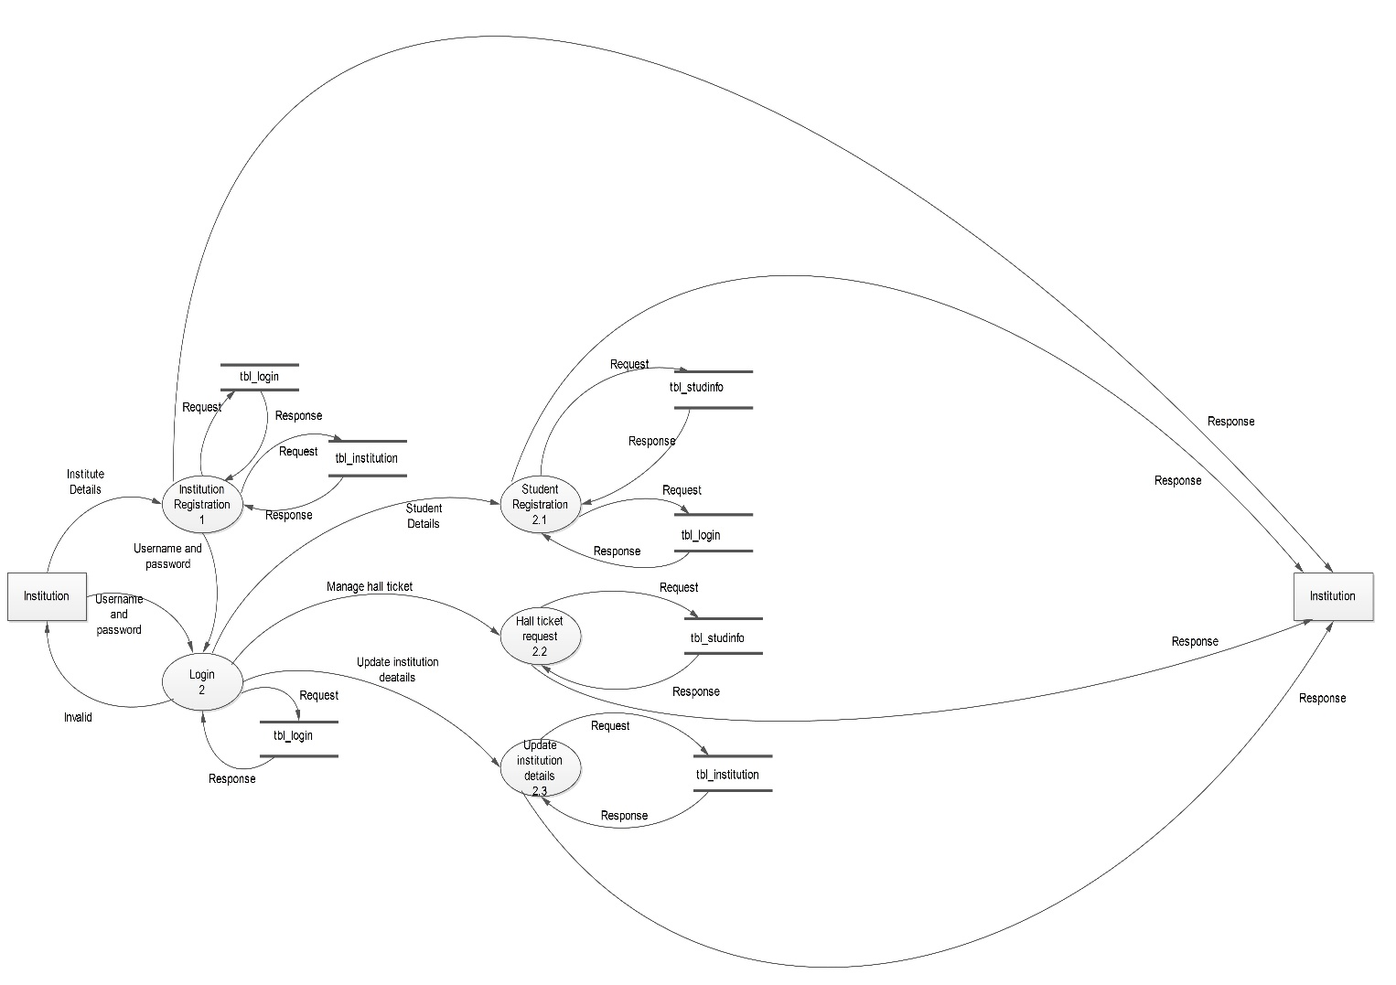

**LEVEL-1 DFD FOR STUDENT**

